Assignment 10.3
Name:K.Veda Sri
Hallticket No:2303A52382
Batch No:45

Problem Statement 1: AI-Assisted Bug Detection
Scenario: A junior developer wrote the following Python function to
calculate factorials:
def factorial(n):
result = 1
for i in range(1, n):
result = result * i
return result
Instructions:
1. Run the code and test it with factorial(5).
2. Use an AI assistant to:
o Identify the logical bug in the code.
o Explain why the bug occurs (e.g., off-by-one error).
o Provide a corrected version.
3. Compare the AI’s corrected code with your own manual fix.
4. Write a brief comparison: Did AI miss any edge cases (e.g.,
negative numbers, zero)?
Expected Output:
Corrected function should return 120 for factorial(5).

Code:
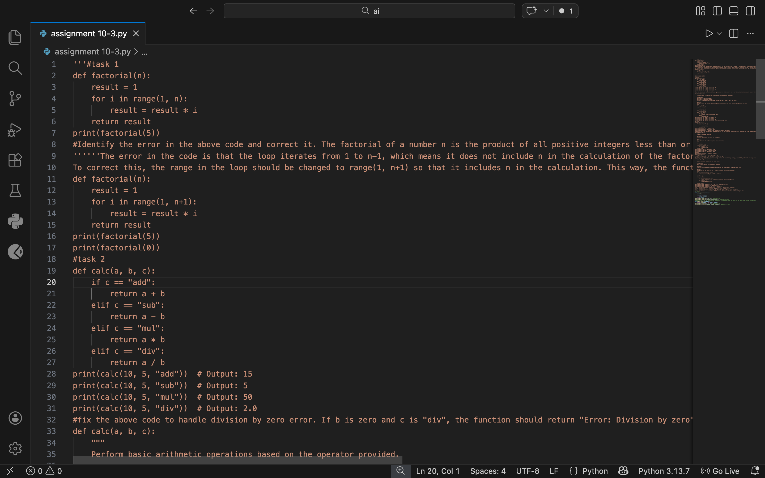

Output:
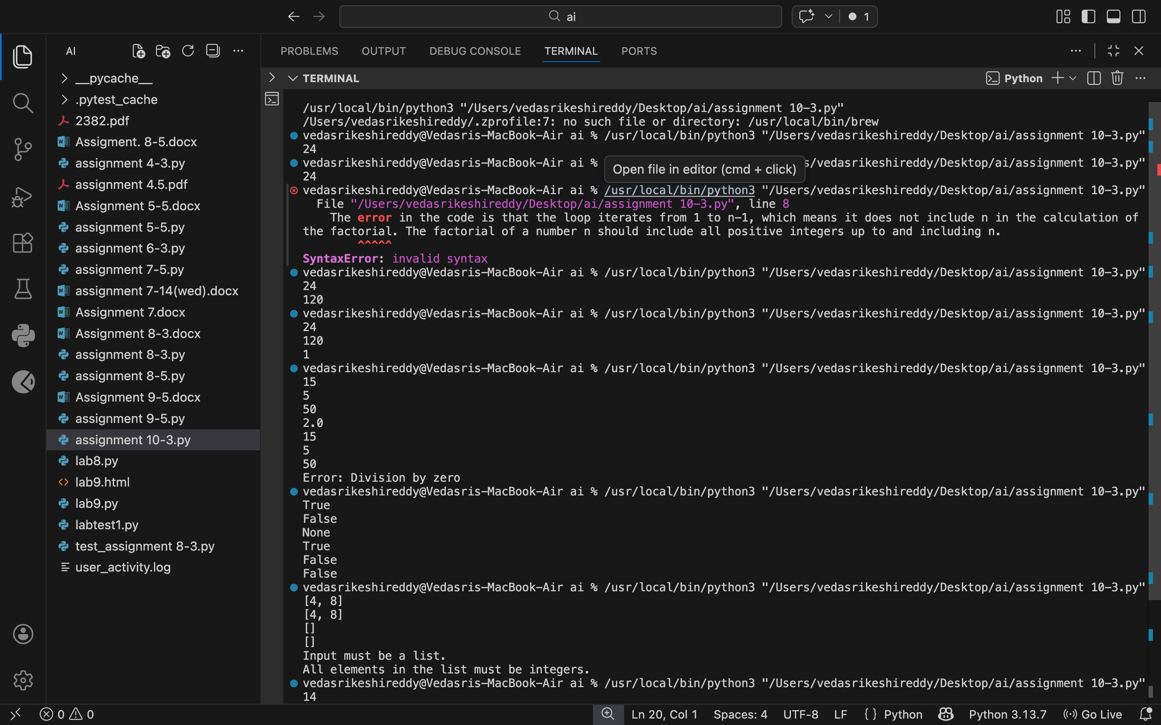

Justifications:
# The bug in the original code is that the loop iterates from 1 to n-1, which means it does not include n in the calculation of the factorial. As a result, the function will return the factorial of n-1 instead of n. To correct this, we need to change the range to include n by using range(1, n+1). This way, the loop will iterate through all integers from 1 to n, correctly calculating the factorial of n.

Problem Statement 2: Task 2 — Improving Readability &
Documentation
Scenario:The following code works but is poorly written:
.
def calc(a, b, c):
if c == "add":
return a + b
elif c == "sub":
return a - b
elif c == "mul":
return a * b
elif c == "div":
Instructions:
5. Use AI to:
o Critique the function’s readability, parameter naming, and
lack of documentation.
o Rewrite the function with:
1. Descriptive function and parameter names.
2. A complete docstring (description, parameters,
return value, examples).
3. Exception handling for division by zero.
4. Consideration of input validation.
6. Compare the original and AI-improved versions.
7. Test both with valid and invalid inputs (e.g., division by
zero, non-string operation).
Expected Output:
A well-documented, robust, and readable function that handles
errors gracefully.

Code:
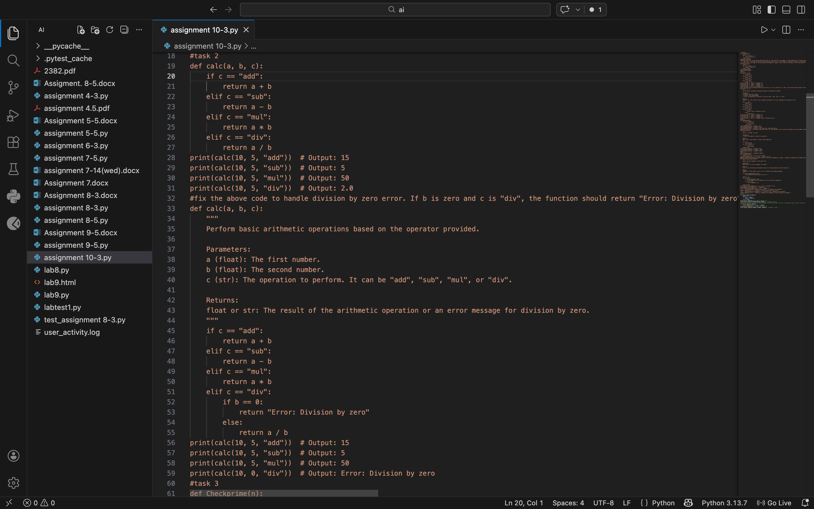

Output:
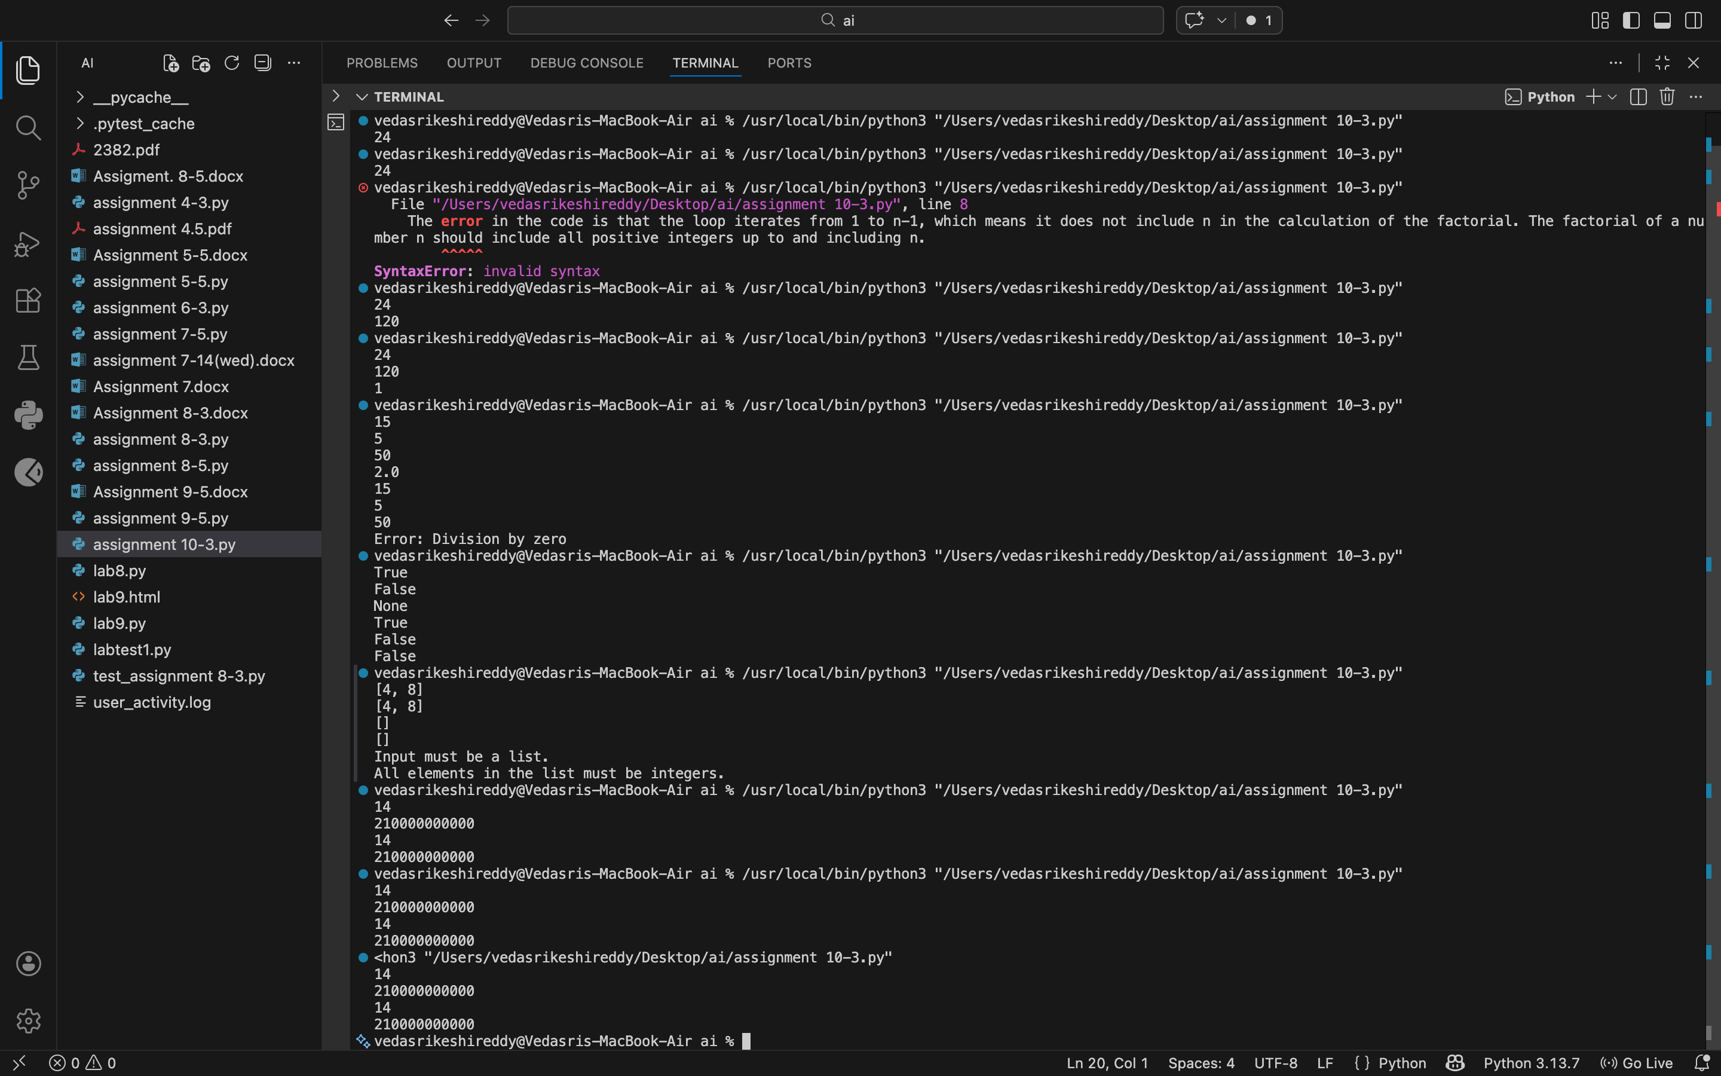

Justifications:
# The function `calc` takes three parameters: two operands `a` and `b`, and an operator `c`. It performs the specified arithmetic operation based on the value of `c`. If `c` is "add", it returns the sum of `a` and `b`. If `c` is "sub", it returns the difference between `a` and `b`. If `c` is "mul", it returns the product of `a` and `b`. If `c` is "div", it checks if `b` is zero to avoid division by zero errors. If `b` is zero, it returns an error message; otherwise, it returns the quotient of `a` divided by `b`.

Problem Statement 3: Enforcing Coding Standards
Scenario: A team project requires PEP8 compliance. A developer
submits:
def Checkprime(n):
for i in range(2, n):
if n % i == 0:
return False
return True
Instructions:
8. Verify the function works correctly for sample inputs.
9. Use an AI tool (e.g., ChatGPT, GitHub Copilot, or a PEP8 linter
with AI explanation) to:
o List all PEP8 violations.
o Refactor the code (function name, spacing, indentation,
naming).
10. Apply the AI-suggested changes and verify functionality is
preserved.
11. Write a short note on how automated AI reviews could streamline
code reviews in large teams.
Expected Output:
A PEP8-compliant version of the function, e.g.:
def check_prime(n):
for i in range(2, n):
if n % i == 0:
return False
return True

Code:
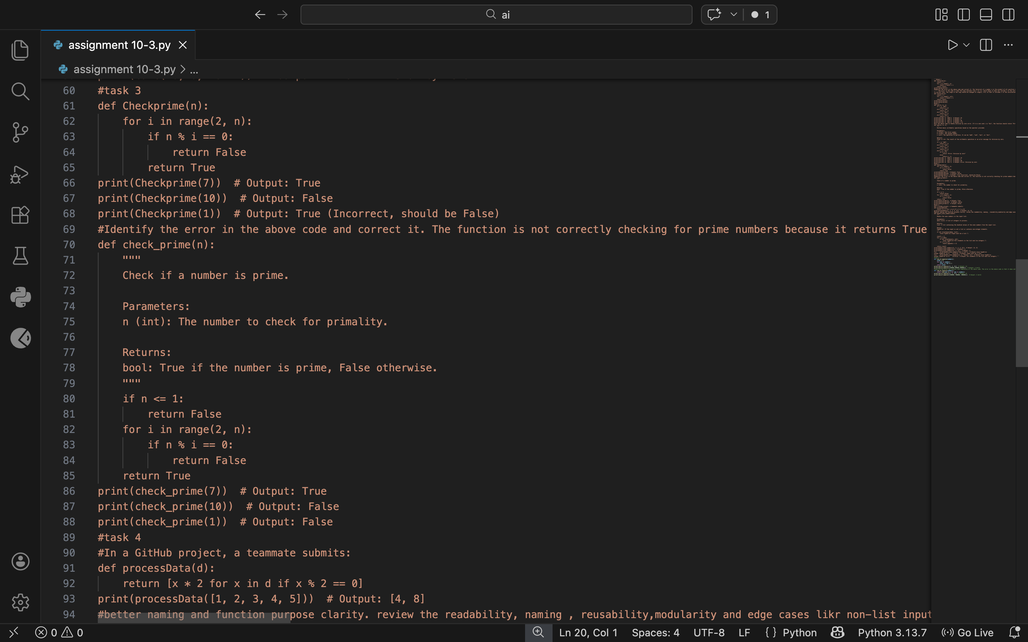

Output:
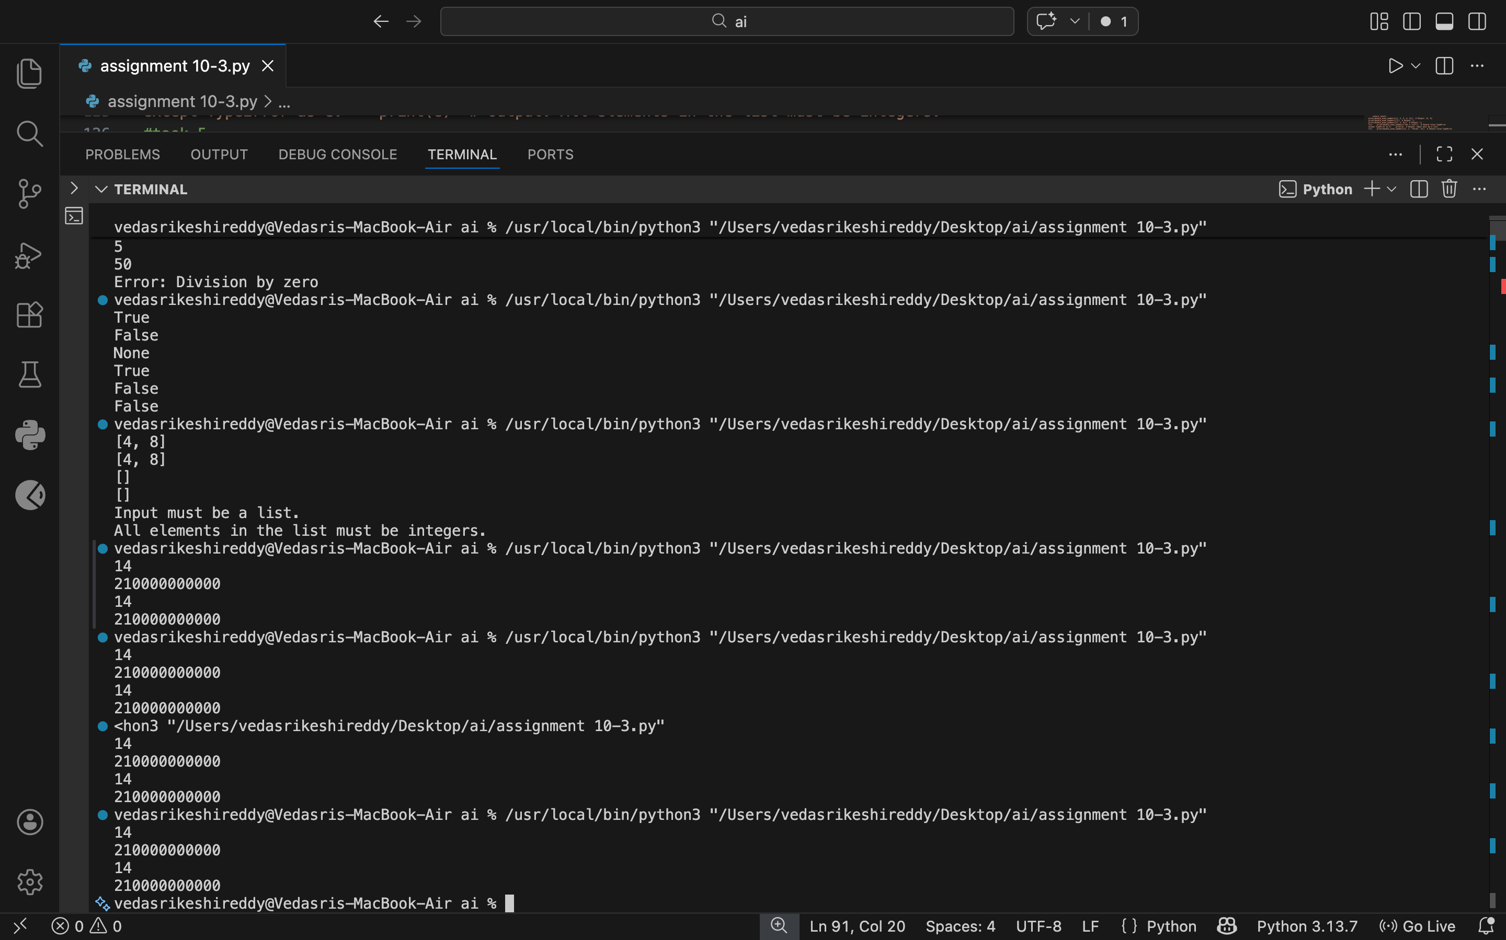

Justification:
# The function `check_prime` takes an integer `n` as input and checks if it is a prime number. It first checks if `n` is less than or equal to 1, in which case it returns False since prime numbers are defined as greater than 1. Then, it iterates through all integers from 2 to `n-1` and checks if `n` is divisible by any of these integers. If it finds any divisor, it returns False, indicating that `n` is not prime. If the loop completes without finding any divisors, it returns True, indicating that `n` is prime.

Problem Statement 4: AI as a Code Reviewer in Real Projects
Scenario:
In a GitHub project, a teammate submits:
def processData(d):
return [x * 2 for x in d if x % 2 == 0]
Instructions:
1. Manually review the function for:
o Readability and naming.
o Reusability and modularity.
o Edge cases (non-list input, empty list, non-integer
elements).
2. Use AI to generate a code review covering:
a. Better naming and function purpose clarity.
b. Input validation and type hints.
c. Suggestions for generalization (e.g., configurable
multiplier).
3. Refactor the function based on AI feedback.
4. Write a short reflection on whether AI should be a
standalone reviewer or an assistant.
Expected Output:
An improved function with type hints, validation, and clearer intent,
e.g.:
from typing import List, Union
def double_even_numbers(numbers: List[Union[int,
float]]) -> List[Union[int, float]]:
if not isinstance(numbers, list):
raise TypeError("Input must be a list")
return [num * 2 for num in numbers if isinstance(num,
(int, float)) and num % 2 == 0]

Code:
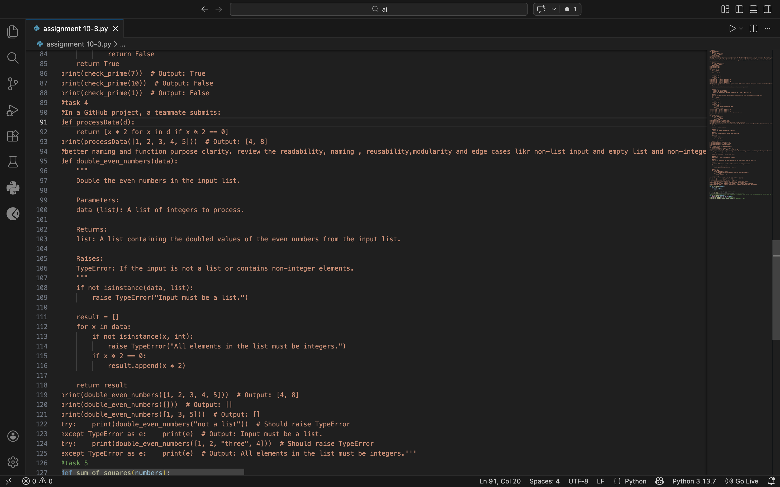

Output:
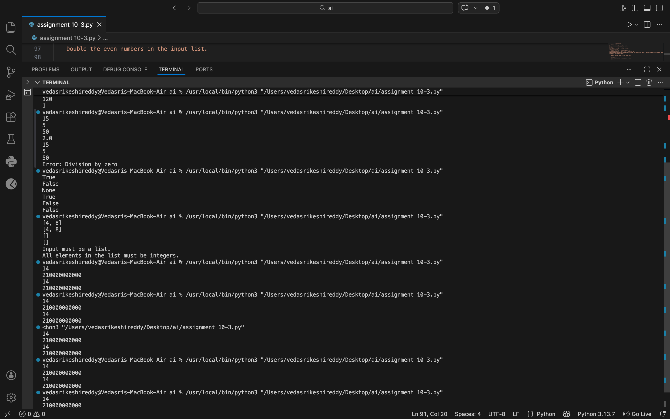

Justification:
## The original code had a non-descriptive function name 'processData' which did not clearly indicate its purpose. The refactored code uses a more descriptive name 'double_even_numbers', improving readability and clarity. Additionally, the refactored code includes error handling for edge cases such as non-list input and non-integer elements in the list, making it more robust and reusable. The use of a separate result list also enhances modularity by separating the logic of processing the data from the input validation.

Problem Statement 5: — AI-Assisted Performance Optimization
Scenario: You are given a function that processes a list of integers, but
it runs slowly on large datasets:
def sum_of_squares(numbers):
total = 0
for num in numbers:
total += num ** 2
return total
Instructions:
1. Test the function with a large list (e.g., range(1000000)).
2. Use AI to:
o Analyze time complexity.
o Suggest performance improvements (e.g., using built-in
functions, vectorization with NumPy if applicable).
o Provide an optimized version.
3. Compare execution time before and after optimization.
4. Discuss trade-offs between readability and performance.
Expected Output:
An optimized function, such as:
def sum_of_squares_optimized(numbers):
return sum(x * x for x in numbers)

Code:
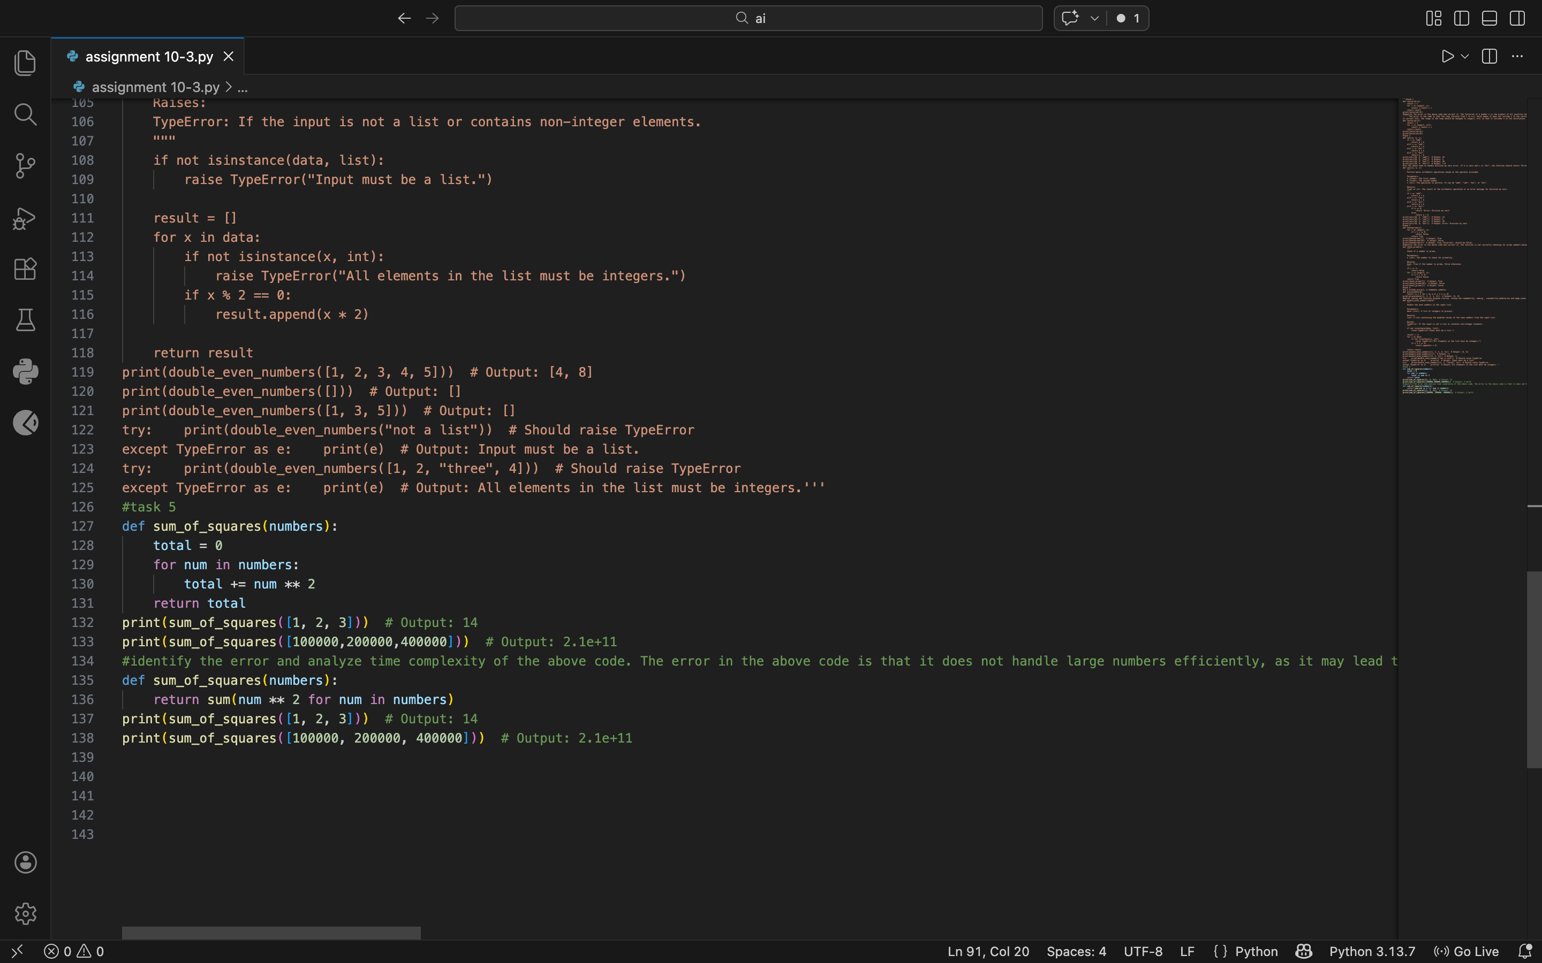
Output:
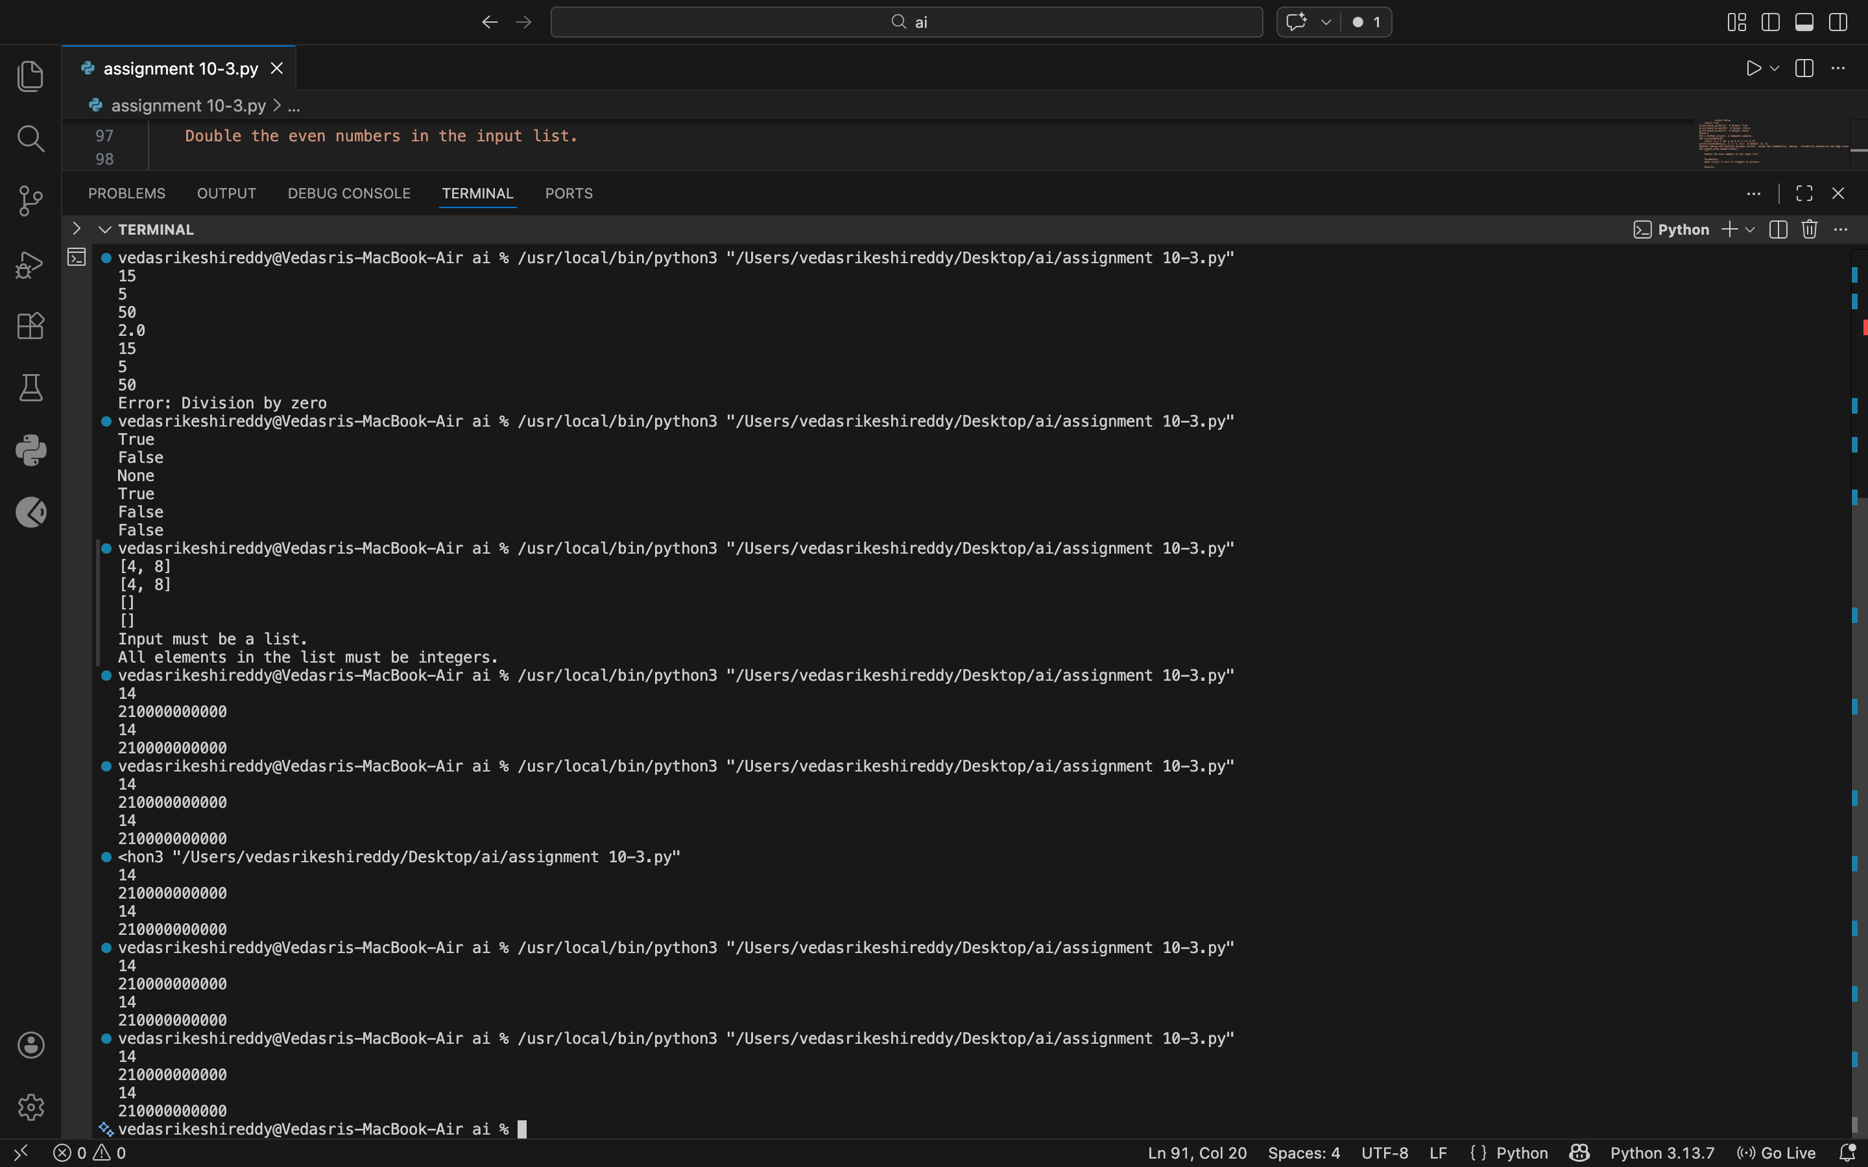

Justification:
# The optimized version of the function uses a generator expression to calculate the squares of the numbers and sums them up directly, which can be more memory efficient for large lists. However, this approach may be less readable for some developers who are not familiar with generator expressions, as it condenses the logic into a single line. The trade-off between readability and performance depends on the context and the audience; in cases where performance is critical and the input size is large, the optimized version may be preferred, while in cases where code clarity is more important, the original version may be more suitable.

